## **Objectives**

* Explain React components

React components are the building blocks of any React application. They allow you to split the UI into independent, reusable pieces, and think about each piece in isolation. A component returns a portion of JSX (JavaScript XML) code that defines what should be rendered on the screen.

* Identify the differences between components and JavaScript functions

|  |  |  |
| --- | --- | --- |
| Feature | JavaScript Function | React Component |
| Purpose | Used for general logic or calculations | Used to build UI elements |
| Return Value | Returns data or values | Returns JSX (UI code) |
| Lifecycle Methods | Not applicable | Can use lifecycle methods (in class components) |
| JSX Support | Not inherently supported | Designed to return and handle JSX |
| React Integration | Not automatically recognized by React | Recognized by React and used in rendering |

* Identify the types of components

Types of Components:

1. Class Components
2. Function Components

* Explain class component

**Class Component:**

A class component is a JavaScript class that extends React.Component. It can hold and manage its own state and can use lifecycle methods such as componentDidMount, componentDidUpdate, and componentWillUnmount.

**Example:**

import React, { Component } from 'react';

class Welcome extends Component {

render() {

return <h1>Hello, {this.props.name}</h1>;

}

}

* Explain function component

**Function Component:**

A function component is a simpler way to write components. It is just a plain JavaScript function that accepts props as an argument and returns JSX. With the introduction of Hooks (like useState and useEffect), function components can now use state and other React features.

**Example:**

import React from 'react';

function Welcome(props) {

return <h1>Hello, {props.name}</h1>;

}

* Define component constructor

The constructor is a special method used in class components for initializing state and binding methods. It is called before the component is mounted.

**Example:**

constructor(props) {

super(props);

this.state = { count: 0 };

}

* Define render() function

The render() function is required in every class component. It returns the JSX that defines what should be displayed on the screen. It is automatically called during the component lifecycle whenever the component needs to re-render.

**Example:**

render() {

return <div>{this.state.count}</div>;

}

## **Notes**

Estimated time to complete this lab: **30 minutes.**

Create a react app for Student Management Portal named StudentApp and create a component named Home which will display the Message “Welcome to the Home page of Student Management Portal”. Create another component named About and display the Message “Welcome to the About page of the Student Management Portal”. Create a third component named Contact and display the Message “Welcome to the Contact page of the Student Management Portal”. Call all the three components.

1. Create a React project named “StudentApp” type the following command in terminal of Visual studio:



1. Create a new folder under Src folder with the name “Components”. Add a new file named “Home.js”
2. Type the following code in Home.js

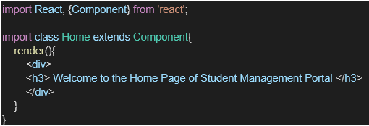

1. Under Src folder add another file named “About.js”
2. Repeat the same steps for Creating “About” and “Contact” component by adding a new file as ”About.js”, “Contact.js” under “Src” folder and edit the code as mentioned for “Home” Component.
3. Edit the App.js to invoke the Home, About and Contact component as follows:

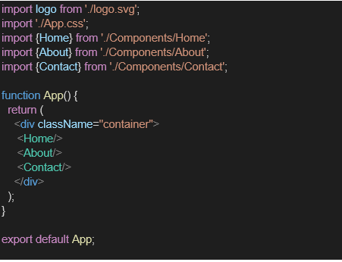

1. In command Prompt, navigate into StudentApp and execute the code by typing the following command:



1. Open browser and type “localhost:3000” in the address bar:

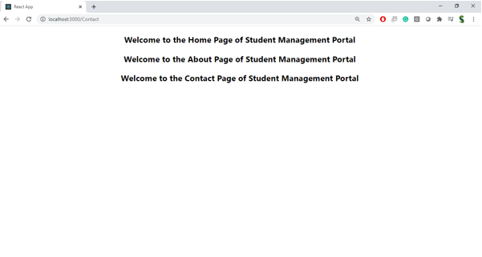

HANDS-ON:

